BOTSWANA TALENT BRIDGE
Website Specification Document
Connecting Botswana's Talent to Opportunity
Purpose
The main purpose of Botswana Talent Bridge is to centralise job opportunities across Botswana into one accessible digital platform, making it easier for job seekers to discover, access, and apply for employment opportunities. The platform bridges the gap between skilled candidates and employers, accelerating the country's workforce development.

Target Audience
Demographics
- Age: 18 – 65 years
- Location: Botswana (locally based users)
- Employment Status: Unemployed individuals, internship seekers, and attachment seekers
Technical Aptitude
- Moderate digital literacy
- Comfortable using basic web browsing
- Familiar with e-mail and online forms

Type of Website
Botswana Talent Bridge is a job information website that aggregates and displays employment opportunities in a single, centralised location. It enables users to easily discover roles through descriptive listings and smart filters. The design is clean, user-friendly, and built to accommodate users across all levels of digital literacy.

Information Design & Taxonomy
The platform adopts a simple and clear layout to ensure users can locate job information quickly and without friction. Every page maintains a consistent structure comprising a navigation bar at the top, main content in the centre, and a footer at the bottom. The site follows a hierarchical layout, starting from the Home Page and branching into key sections:

- Home
- About Us
- Jobs
- CVs & Candidates
- Post a Job
- Contact Us

User Navigation Flow
Users land on the Home Page and are guided through an intuitive flow toward their goal — whether searching for jobs, uploading a CV, or posting a vacancy. Clear calls-to-action on each page direct both job seekers and employers to the most relevant sections of the platform.

Page Template Design
The following pages are included in the Botswana Talent Bridge platform. Wireframes for each page are presented below.

— Wireframes —
— 1 · Home Page —
The main landing page featuring a prominent search bar, real-time platform statistics, featured job listings, and a category browser to help users navigate quickly to relevant roles.
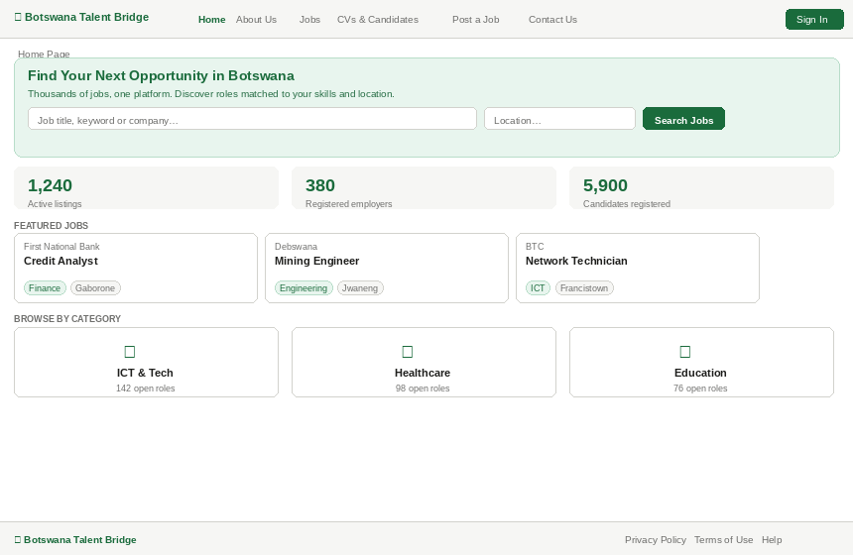
Wireframe: Home Page — hero search, stats, featured jobs, and category browser

— 2 · Jobs Page —
A searchable, filterable listing of all available job opportunities. A sidebar panel allows users to narrow results by job type, sector, and location.
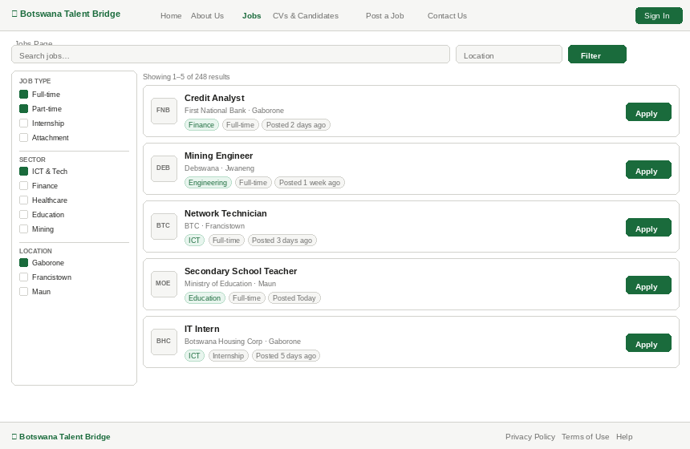
Wireframe: Jobs Page — filter sidebar and paginated job listings with apply buttons

— 3 · CVs & Candidates Page —
A directory enabling employers to browse registered candidate profiles. Each card displays the candidate's role, sector, and location, with a direct link to view their CV. A prominent upload slot allows new candidates to register.
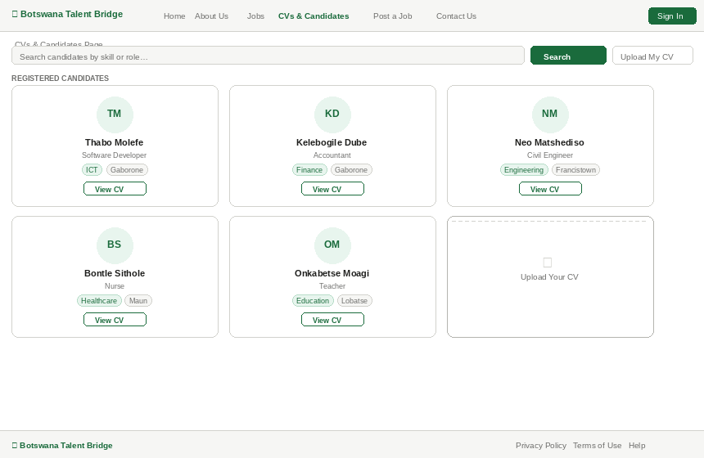
Wireframe: CVs & Candidates Page — candidate profile grid with CV upload slot

— 4 · Post a Job Page —
A structured form enabling employers to submit new job vacancies. Fields capture the job title, company, sector, type, salary, location, description, requirements, deadline, and contact email.
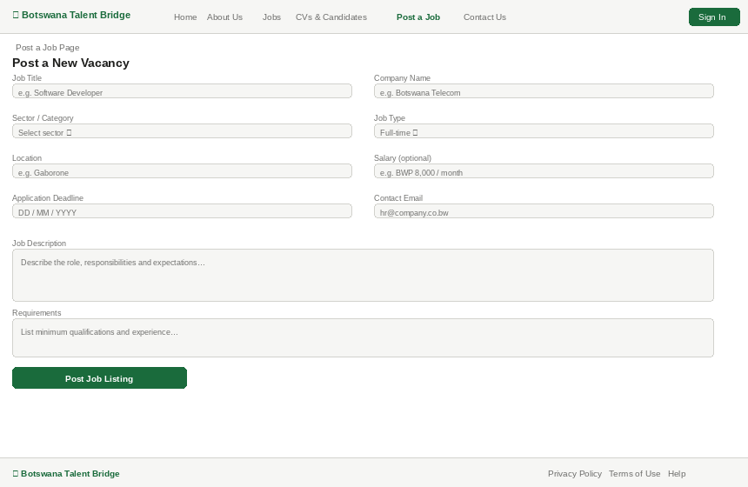
Wireframe: Post a Job Page — employer vacancy submission form

— 5 · About Us Page —
An introduction to Botswana Talent Bridge, its mission and vision, and the team behind the platform. Presented in a clean card layout with team member profiles.
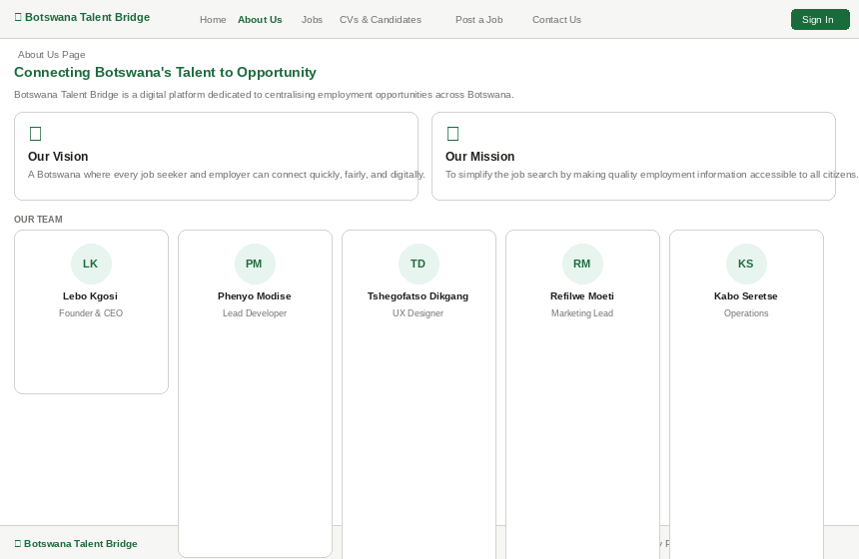
Wireframe: About Us Page — mission, vision, and team section

— 6 · Contact Us Page —
A two-column layout combining a contact form with the organisation's key contact details — email, phone, address, office hours, and social media links.
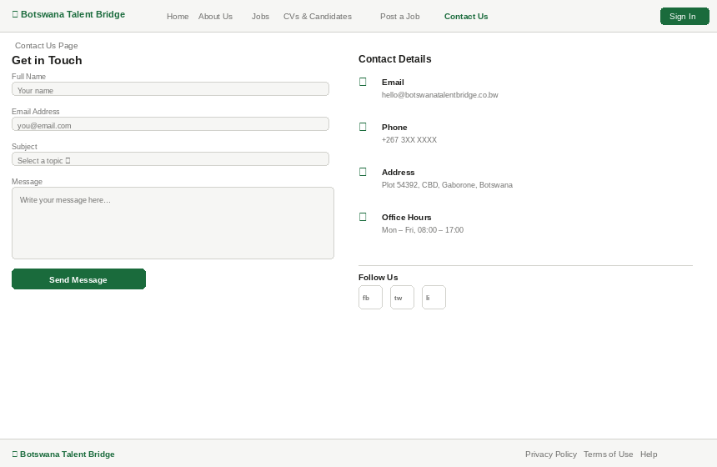
Wireframe: Contact Us Page — contact form and organisational details

— 7 · Job Details View Page —
A dedicated page for each job listing, displaying the full job description, responsibilities, and requirements. A sticky sidebar shows the salary, closing date, and prominent apply and save buttons.
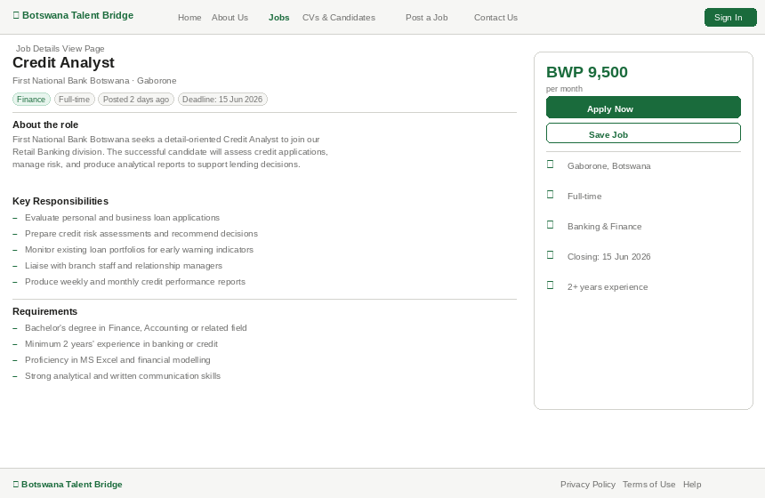
Wireframe: Job Details View Page — full listing with sticky application sidebar

Technical Brief
Botswana Talent Bridge will be developed as a web-based application that enables users to find and search for job opportunities online. The system is designed to be simple, efficient, and easy to use across all device types.
Front-End
- HTML will define the structure and content of each web page.
- CSS will handle the visual design, styling, and responsive layout.
- JavaScript will power dynamic functionality — including job searching, filtering, and simulated data interactions — enabling a smooth experience without requiring a live server during development.
Back-End & Database
- A database will store all critical information, including job listings, company profiles, and candidate details.
- Backend logic will manage data retrieval, submission, and display across the platform.
Hosting & Deployment
- The platform will be hosted online. During testing and initial deployment, platforms such as GitHub Pages will be used.
Responsiveness
- The website will be fully responsive — optimised for mobile phones, tablets, and desktop computers.
- Mobile accessibility is a key priority, as a significant portion of users in Botswana access digital services via smartphones.

Botswana Talent Bridge · Connecting Talent to Opportunity

